Figure 7AB.- (A) A fully plowed plot (old technique) before the planting of Quercus suber in the Marmora Forest; (B) Planting site preparation (new technique) by plowing alternating strips

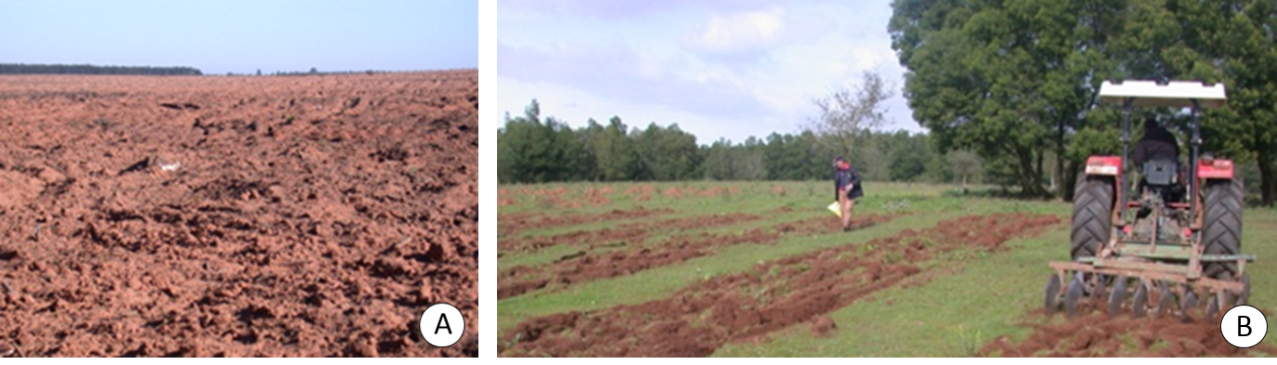
Figure 7 (A-B)

