Figure 3AB.- (A) Monthly mortality of oak seedlings in canton B (plot BV10_NE) (from Lumaret et al. 2005); (B) Mortality of cork oak seedlings in relation to their initial number in planting holes (block BV10-SW) (from Ghaioule et al. 2007).

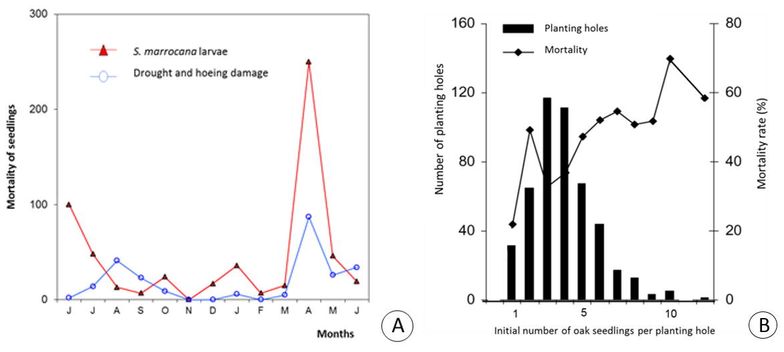
Figure 3 (A - B)

