Figure 2AB.- (A) Female (above) and male (below) of Sphodroxia maroccana; (B) Body orientation of the female when emitting sex pheromone.

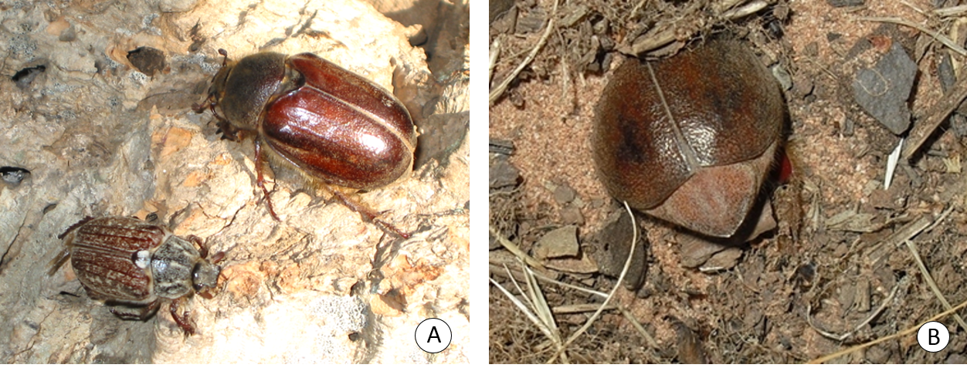
Figure 2 (A – B)

