Figure 1AB.- (A) Mamora Forest, Quercus suber trees and clumps of the Mediterranean dwarf palm (Chamaerops humilis); (B) Natural vegetation in the absence of grazing (Ain Johra Hunting Reserve).

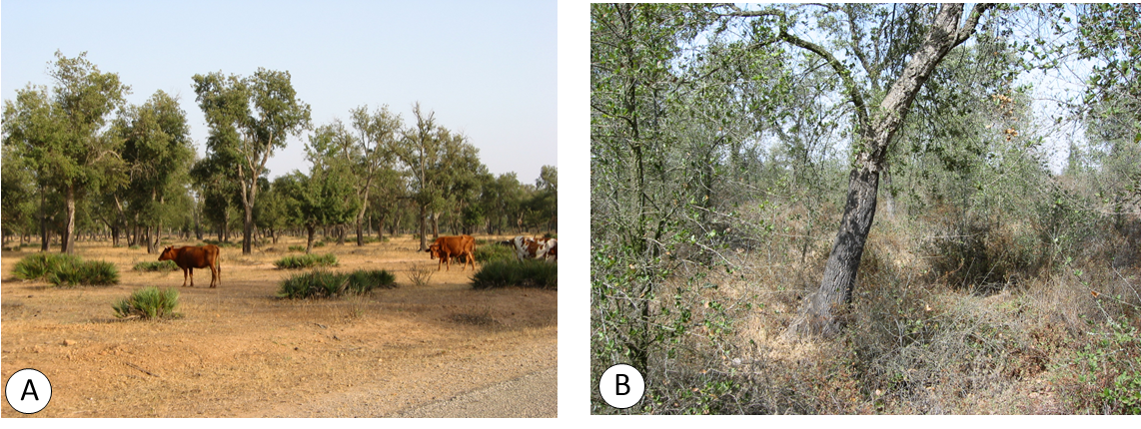
Figure 1 (A – B)

